Children’s Product Certificate
Date of Certificate Apr 11 ,2023
Product Overview
Product name: TOY CAR
Item Number: 370-195 (5003)
Date of Manufacture: Apr 1 ,2023
Manufacture: JinJiang Nobel Star Toys Co.,Ltd
Address of Manufacture: NO.3 QuanYuan Road, WuLi District, Jinjiang Economic Development Zone, Jinjiang City, Fujian, China
Imported By: Aosom LLC
27150 SW Kinsman Rd
Wilsonville, OR 97070
T: 503.746.5886
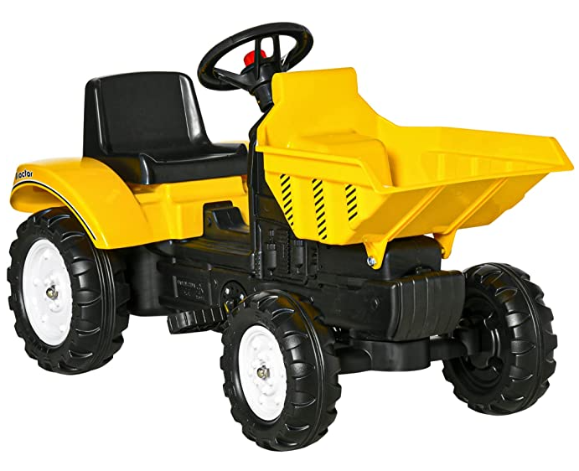

Product Reference Image

Testing and Records Overview
Aosom LLC
27150 SW Kinsman Rd
Wilsonville, OR 97070
Corey Shull
T: 503.746.5886
Eurofins Product Test Service(Shanghai)Co.,Ltd
Building 18, No.2168 Chenghang Highway, Minhang District, Shanghai, China
Tel: +86 510 8821 4567
Fax: +86 510 8820 0428
E-mail: info@eurofins.com
Certification Issued and Test Records Maintained By
Aosom LLC certifies that the above product complies with the following rules, banes, regulations and standards:
Test Location and Contact Information
Test Date: Sep 21,2022
