Children’s Product Certificate
Date of Certificate 2023-11-24
Product Overview
Product name: Kids Scooter
Item Number: 371-017BK
Date of Manufacture: 2024-03-30
Manufacture: Hangzhou xinguang Bicycle Industry Co.,Ltd.
Address of Manufacture: 72-1 ZHA SHANG, TAOYUAN VILLAGE,
PUYANG TOWN, XIAOSHAN DISTRICT,
HANGZHOU CITY, ZHEJIANG PROVINCE, CHINA
Imported By: Aosom LLC
27150 SW Kinsman Rd
Wilsonville, OR 97070
T: 503.746.5886
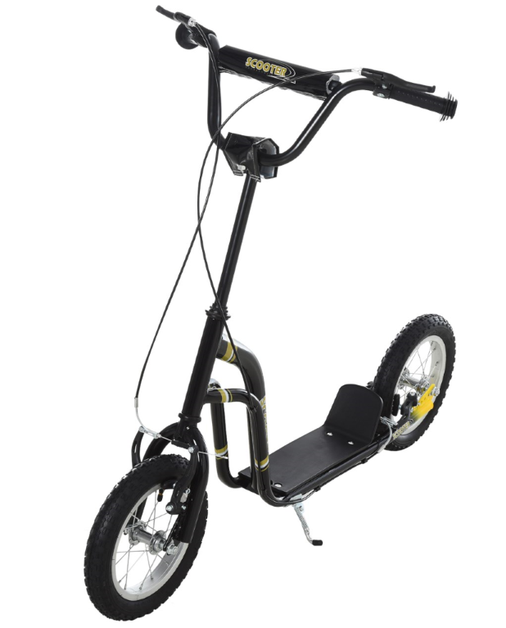

Product Reference Image

Testing and Records Overview
INTERTEK TESTING SERVICES LTD.
ZHEJIANG.
Building No.2, Juanhu Science and Technology
Innovation Park, No. 500 East Shuiyueting Road,
Haining City, Zhejiang Province,China. 314400
Phone: +86 573 87137200
www.intertek.com

Aosom LLC
27150 SW Kinsman Rd
Wilsonville, OR 97070
Corey Shull
T: 503.746.5886
Certification Issued and Test Records Maintained By
Aosom LLC certifies that the above product complies with the following rules, banes, regulations and standards:
Test Location and Contact Information
Test Date: 2023.09.28

