Children’s Product Certificate

Date of Certificate Feb19,2024
Product Overview
Product name: Children’s Go Kart
Item Number: 370-276V00RD（G18）
Date of Manufacture: April 6,2024
Manufacture: PINGHU CITY GOLDTIER CHILDREN PRODUCTS MANUFACTURE CO., LTD
Address of Manufacture: JIAXING CITY, ZHEJIANG PROVINCE
Imported By: Aosom LLC
27150 SW Kinsman Rd
Wilsonville, OR 97070
T: 503.746.5886
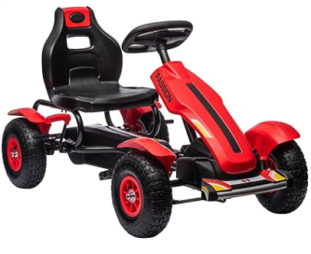

Product Reference Image

Testing and Records Overview
Aosom LLC
27150 SW Kinsman Rd
Wilsonville, OR 97070
Corey Shull
T: 503.746.5886
Intertek Testing Services Ltd .Zhejiang, Ningbo Branch
5/F No. 6 Building, Lingyun Industry Park, No.1177 Lingyun Road, Ningbo National Hi-Tech Zone, Ningbo China, 315000
Certification Issued and Test Records Maintained By
Aosom LLC certifies that the above product complies with the following rules, banes, regulations and standards:
Test Location and Contact Information
Test Date: Jan 02-16,2024
