Children’s Product Certificate
Date of Certificate Aug. 8,2025
Product Overview
Product name: Kids rocking horse
Item Number: 330-205V00BN
Date of Manufacture: Aug. 05,2025
Manufacture: Yizheng Jian Lin Arts Company
Address of Manufacture:Xianggou Village,Dayi Town,Yizheng City,Jiang Su Province ,China
Imported By: Aosom LLC
27150 SW Kinsman Rd
Wilsonville, OR 97070
T: 503.746.5886
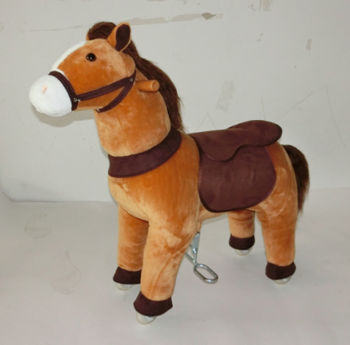

Product Reference Image

Testing and Records Overview
Aosom LLC
27150 SW Kinsman Rd
Wilsonville, OR 97070
Corey Shull
T: 503.746.5886
corey@aosom.com
Eurofins MTS Consumer Product Testing(Shanghai)Co.,Ltd. No. 105,Guangzhong Road, Minhang District,Shanghai,China
Email:info.sh@cpt.eurofinscn.com

Certification Issued and Test Records Maintained By
Aosom LLC certifies that the above product complies with the following rules, banes, regulations and standards:
Test Location and Contact Information
Test Date: Jun. 10,2025
