Children’s Product Certificate
Date of Certificate Dec 29，2025

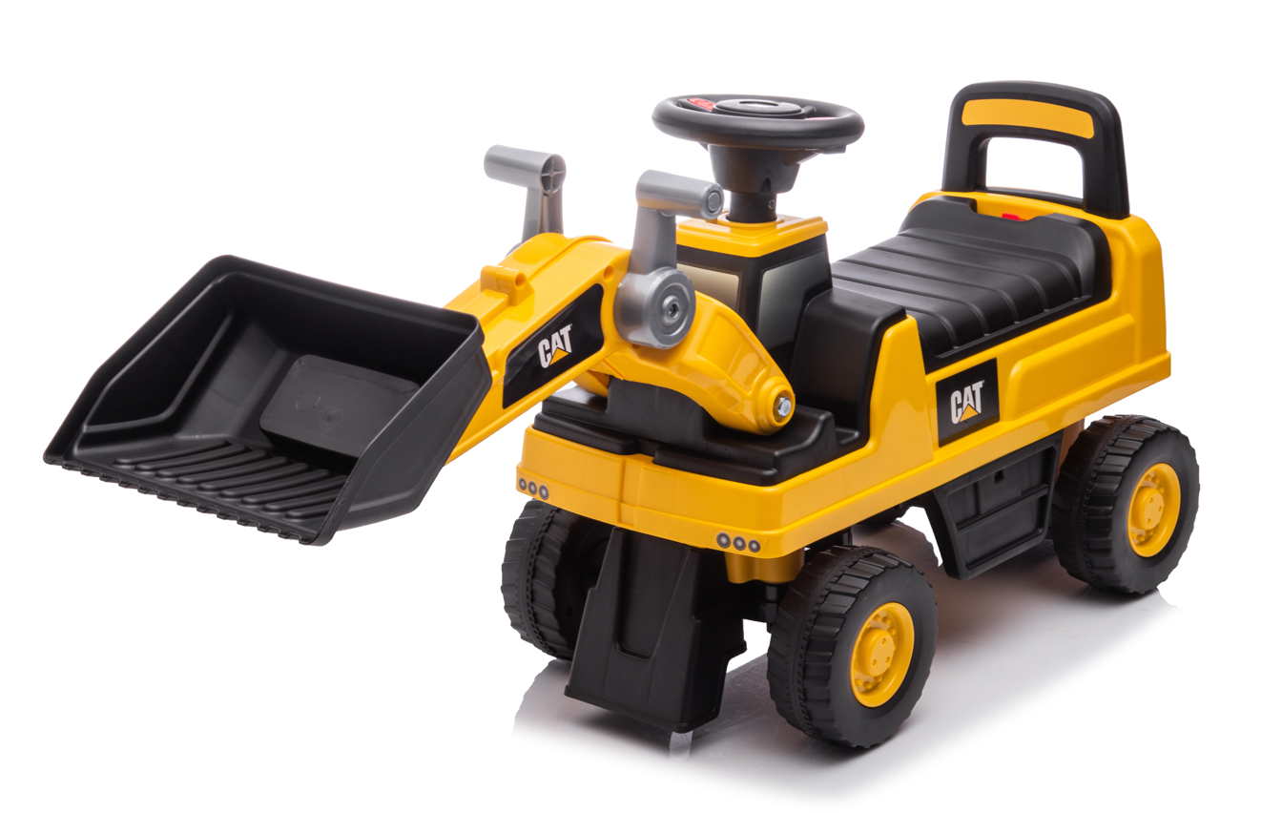

Product Overview
Product name: BABY RIDE ON CAR
Item Number: 370-262V00YL
Date of Manufacture: Nov 3,2025
Manufacture: NINGBO PRINCE TOYS CO.,LTD.
Address of Manufacture: NO.777 EAST TAOYUAN ROAD,GUANHAIWEI TOWN,CIXI CITY,ZHEJIANG,CHINA
Imported By: Aosom LLC
7777 Center Ave. Suite 430
Huntington Beach, CA 92647-9998 USA
T: 503.746.5886

Product Reference Image

Testing and Records Overview
Bureau Veritas Testing Technical Service (Zhejiang) Co., Ltd
1F,6F east 7F east,8F,building B,No.66,Qingyi Road,Juxian Sub-district,High-teach Zone,Ningbo,Zhejiang,China Tel:86-574-870913333

Aosom LLC
7777 Center Ave. Suite 430
Huntington Beach, CA 92647-9998 USA
Email:corey@aosom.com
Certification Issued and Test Records Maintained By
Aosom LLC certifies that the above product complies with the following rules, banes, regulations and standards:
Test Location and Contact Information
Test Date: Nov 3,2025

