Children’s Product Certificate
Date of Certificate APR 22,2024
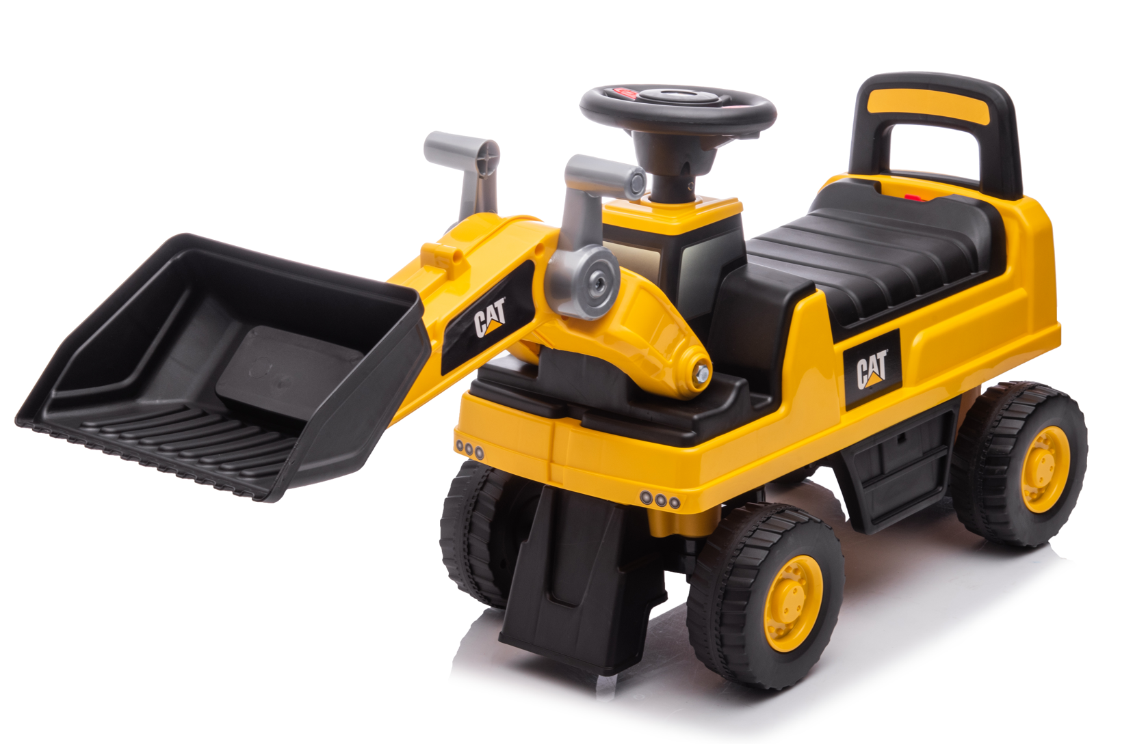

Product Overview
Product name: BABY RIDE ON CAR
Item Number: 370-262V00YL
Date of Manufacture: May 25,2024
Manufacture: NINGBO PRINCE TOYS CO.,LTD.
Address of Manufacture: NO.777 EAST TAOYUAN ROAD,GUANHAIWEI TOWN,CIXI CITY,ZHEJIANG,CHINA
Imported By: Aosom LLC
27150 SW Kinsman Rd
Wilsonville, OR 97070
T: 503.746.5886

Product Reference Image

Testing and Records Overview
TÜV Rheinland/CCIC (Ningbo) Co., Ltd.
3F Building C13, R&D Park, No.32 , Lane 299 Guanghua Road, National Hi-Tech Zone,
Ningbo, 315048, P. R. China
Aosom LLC
27150 SW Kinsman Rd
Wilsonville, OR 97070
Corey Shull
T: 503.746.5886
Certification Issued and Test Records Maintained By
Aosom LLC certifies that the above product complies with the following rules, banes, regulations and standards:
Test Location and Contact Information
Test Date: APR 17,2024
