Children’s Product Certificate
Date of Certificate 01-Apr-2024
Product Overview
Product name: Children storage cabinet
Item Number: 311-053V01BU (LY-2303)
Date of Manufacture: 10-Apr-2024
Manufacture: Liyou Industrial Co.,Ltd
Address of Manufacture: Yangwan industrial area, QiaoXia Town, Yongjia County,Zhejiang,China
Imported By: Aosom LLC
27150 SW Kinsman Rd
Wilsonville, OR 97070
T: 503.746.5886
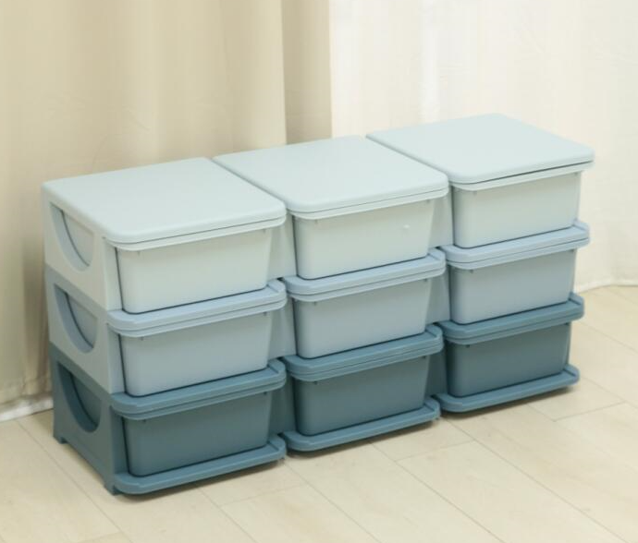

Product Reference Image

Testing and Records Overview
Aosom LLC
27150 SW Kinsman Rd
Wilsonville, OR 97070
Corey Shull
T: 503.746.5886
Eurofins Product Testing Service (Shanghai) Co.,Ltd
Building 18, No.2168 Chenhang,Highway,Minhang District,Shanghai, China
Phone: +86 21 61819181-6161
Fax: +86 21 61819180
LilyShen@eurofins.com
Certification Issued and Test Records Maintained By
Aosom LLC certifies that the above product complies with the following rules, banes, regulations and standards:
Test Location and Contact Information
Test Date: 04-Mar-2024
