Children’s Product Certificate
Date of Certificate Jan30,2024
Product Overview
Product name: Foot-floor toy
Item Number: 370-096BK/370-096PK（G09）
Date of Manufacture: April 6,2024
Manufacture: PINGHU CITY GOLDTIER CHILDREN PRODUCTS MANUFACTURE CO., LTD
Address of Manufacture: JIAXING CITY, ZHEJIANG PROVINCE
Imported By: Aosom LLC
27150 SW Kinsman Rd
Wilsonville, OR 97070
T: 503.746.5886
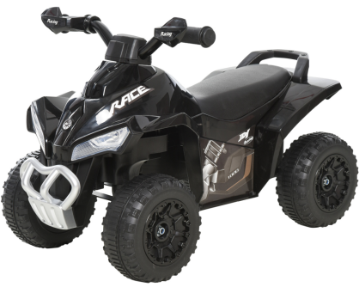

Product Reference Image

Testing and Records Overview
Aosom LLC
27150 SW Kinsman Rd
Wilsonville, OR 97070
Corey Shull
T: 503.746.5886
Intertek Testing Services Ltd .Zhejiang, Ningbo Branch
5/F No. 6 Building, Lingyun Industry Park, No.1177 Lingyun Road, Ningbo National Hi-Tech Zone, Ningbo China, 315000
Tel: +86 574 8818 3650
Fax: +86 574 88183680
www.intertek.com
www.intertek.com.cn
Certification Issued and Test Records Maintained By
Aosom LLC certifies that the above product complies with the following rules, banes, regulations and standards:
Test Location and Contact Information
Test Date: Jan 08-24,2024
