Children’s Product Certificate
Date of Certificate 30-Apr-2024
Product Overview
Product name: ROCKING HORSE
Item Number: 330-123（WM19029）
Date of Manufacture: 3-May-2024
Manufacture: ZHEJIANG WANMEI TOYS CO.,LTD
Address of Manufacture: WENZHOU CITY, ZHEJIANG PROVINCE
Imported By: Aosom LLC
27150 SW Kinsman Rd
Wilsonville, OR 97070
T: 503.746.5886
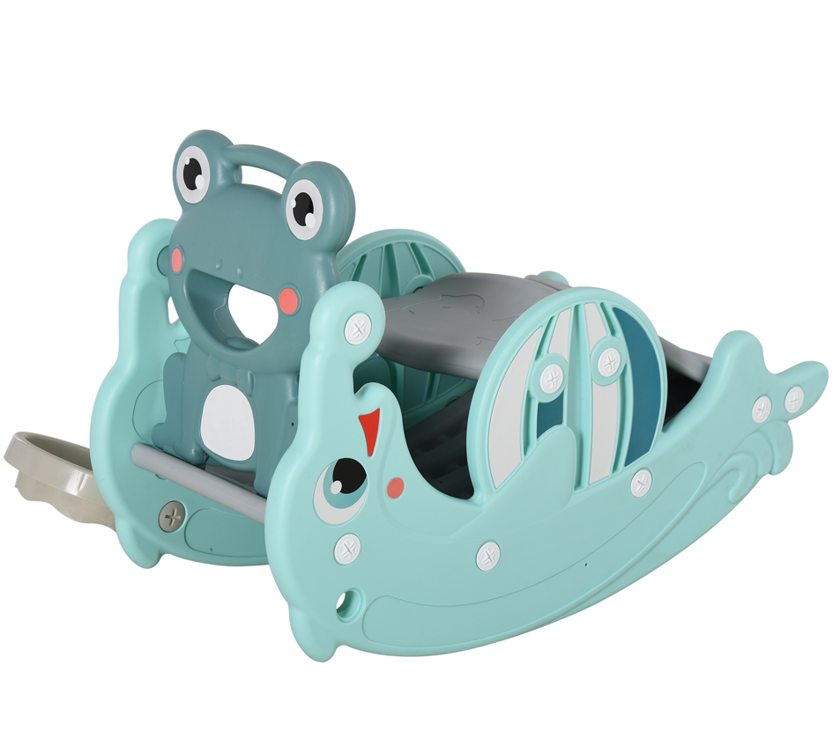

Product Reference Image

Testing and Records Overview
Aosom LLC
27150 SW Kinsman Rd
Wilsonville, OR 97070
Corey Shull
T: 503.746.5886
Certification Issued and Test Records Maintained By
Test Location and Contact Information
Test Date: 08-Apr-2024
Eurofins MTS Consumer Products Testing(Shanghai) Co.,Ltd
No.105,Guangzhou Road,Minhang District,Shanghai,China
0571-88904890
Aosom LLC certifies that the above product complies with the following rules, banes, regulations and standards:
