Children’s Product Certificate
Date of Certificate Dec 21,2023
Product Overview
Product name: Kids Soft Play Set
Item Number: 3D0-006V03MX
Date of Manufacture: May 2024
Manufacture: Nantong Tianshu Sports Equipment Co.,Ltd
Address of Manufacture: No.8,Group 5,Zhenhe Village,Chahe Town,Rudong County,Nantong City
Imported By: Aosom LLC
27150 SW Kinsman Rd
Wilsonville, OR 97070
T: 503.746.5886
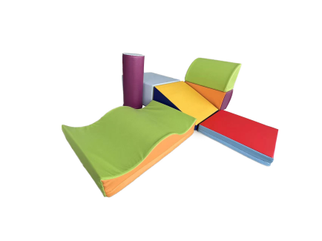

Product Reference Image

Test Location and Contact Information
Eurofins MTS Consumer Product Testing (Shanghai) Co., Ltd.
No. 105, Guangzhong Road, Minhang,
Shanghai, China
Eurofins（Shanghai）contact information
Customer service: SallyZhang@eurofins.com/ +86 13116656995
Sales specialist: Diver.Dong@cpt.eurofinscn.com/ +86 13116656995

Certification Issued and Test Records Maintained By
Test Date: May 21,2024
Aosom LLC
27150 SW Kinsman Rd
Wilsonville, OR 97070
Corey Shull
T: 503.746.5886

Records Overview
Aosom LLC certifies that the above product complies with the following rules, banes, regulations and standards:
