Children’s Product Certificate
Date of Certificate April.9th, 2024
Product Overview
Product name: Kid’s Sandbox
Item Number: 343-029 (2076)
Date of Manufacture: January.30th, 204
Manufacture: Fujian Zhangping D-road Forestry Co.,Ltd.
Address of Manufacture: Fushan Industry District, Zhangping City, Fujian, China
Imported By: Aosom LLC
27150 SW Kinsman Rd
Wilsonville, OR 97070
T: 503.746.5886
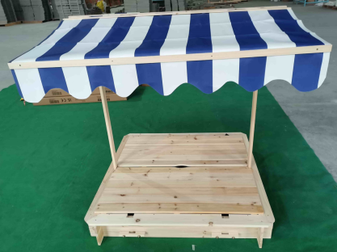

Product Reference Image

Testing and Records Overview
Aosom LLC
27150 SW Kinsman Rd
Wilsonville, OR 97070
Corey Shull
T: 503.746.5886
Certification Issued and Test Records Maintained By
TÜV SÜD Certification and Testing (China) Co., Ltd. Shenzhen Branch
Building 6, Zhiheng Wisdomland Business Park, Nantou Checkpoint Road 2, Nanshan District, Shenzhen 518 052, P.R. China
Phone: +86 755 3332 3260
Fax: +86 755 8828 5299
Email address: Killua.Chen@tuvsud.com

Test Location and Contact Information
Test Date: April.9th, 2024
Aosom LLC certifies that the above product complies with the following rules, banes, regulations and standards:
