Children’s Product Certificate
Date of Certificate 2024-6-18
Product Overview
Product name: Kids storage shelf with 6 grey bins
Item Number: 311-070V80GY
Date of Manufacture: 2024-04-01
Manufacture: DELTA (FUJIAN) CHILDREN’S PRODUCTS CO., LTD.
Address of Manufacture: JIAN’GANG ROAD, JIANGYIN INDUSTRY CONCENTRATED AREA, FUQING, FUJIAN
Imported By: Aosom LLC
27150 SW Kinsman Rd
Wilsonville, OR 97070
T: 503.746.5886
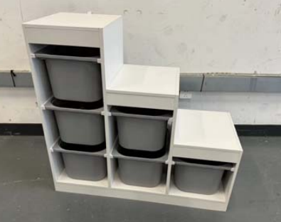

Product Reference Image

Testing and Records Overview
INTERTEK TESTING SERVICES ZHEJIANG LTD.
Building No.2, Juanhu Science and Technology Innovation Park, No.500 East Shuiyueting Road, Haining City, Zhejiang Province, China, 314400
Phone: +86 573 87137200
www.intertek.com

Aosom LLC
27150 SW Kinsman Rd
Wilsonville, OR 97070
Corey Shull
T: 503.746.5886
Certification Issued and Test Records Maintained By
Aosom LLC certifies that the above product complies with the following rules, banes, regulations and standards:
Test Location and Contact Information
Test Date: 2024-4-3 TO 2024-4-12
