Children’s Product Certificate
Date of Certificate May. 15,2024
Product Overview
Product name: kids tricycle
Item Number: 370-024BK(T301B)
Date of Manufacture: Mar. 07,2024
Manufacture: NINGBO FAMILY BABY PRODUCTS CO.,LTD.
Address of Manufacture: #29,PUDI ROAD ,XIAPU INDUSTRIAL
ZONE , NINGBO,P.R.CHINA
Imported By: Aosom LLC
27150 SW Kinsman Rd
Wilsonville, OR 97070
T: 503.746.5886
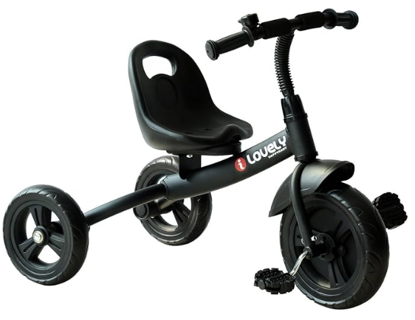

Product Reference Image

Testing and Records Overview
Aosom LLC
27150 SW Kinsman Rd
Wilsonville, OR 97070
Corey Shull
T: 503.746.5886
Intertek Testing Services Ltd .Zhejiang, Ningbo Branch
5/F No. 6 Building, Lingyun Industry Park, No.1177 Lingyun Road, Ningbo National Hi-Tech Zone, Ningbo, China, 315000
Tel: +86 574 8818 3650
Fax: +86 574 8818 3680
www.intertek.com
Certification Issued and Test Records Maintained By
Aosom LLC certifies that the above product complies with the following rules, banes, regulations and standards:
Test Location and Contact Information
Test Date: Mar. 14,2024
