Children’s Product Certificate
Date of Certificate June 6,2024
Product Overview
Product name: Software Composite Toy
Item Number: 3D0-004
Date of Manufacture: May 25th,2024
Manufacture: NINGBO YINZHOU WANLI SPORTING GOODS CO., LTD
Address of Manufacture: XINCHENG VILLAGE, WUXIANG TOWN, YINZHOU DISTRICT, NINGBO,ZHEJIANG PROVINCE, CHINA
Imported By: Aosom LLC
27150 SW Kinsman Rd
Wilsonville, OR 97070
T: 503.746.5886
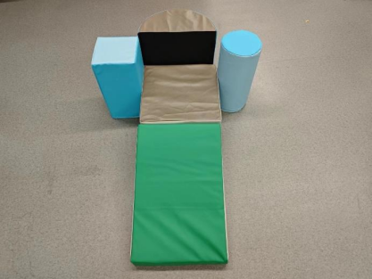

Product Reference Image

Testing and Records Overview
TÜ V SÜ D Certification and Testing (China) Co., Ltd.
Shanghai Branch, Testing Center
Building B,C, No. 1999 and Building D, No. 2059, Duhui
Road, Minhang District, Shangha
Phone: +86 21 60376300
Fax: +86 21 60376350

Aosom LLC
27150 SW Kinsman Rd
Wilsonville, OR 97070
Corey Shull
T: 503.746.5886
Certification Issued and Test Records Maintained By

Aosom LLC certifies that the above product complies with the following rules, banes, regulations and standards:
Test Location and Contact Information
Test Date: April 23,2024

