Children’s Product Certificate
Date of Certificate April 3,2024
Product Overview
Product name: BABY CARRIAGES
Item Number: 370-245V00YL(YD1003)
Date of Manufacture: April 4.2024
Manufacture: SHANTOU YUANDA TOY INDUSTRY CO.LTD
Address of Manufacture: SHANTOU CITY, GUANGDONG
Imported By: Aosom LLC
27150 SW Kinsman Rd
Wilsonville, OR 97070
T: 503.746.5886
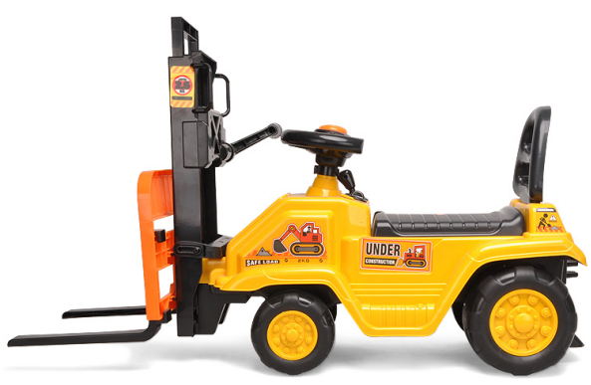

Product Reference Image

Testing and Records Overview
Aosom LLC
27150 SW Kinsman Rd
Wilsonville, OR 97070
Corey Shull
T: 503.746.5886
Guangdong Safety Testing Co., Ltd.
No.1, the 1st North Industry Road, Songshan Lake Sci.&Tech. Park, Dongguan,Guangdong, China
Phone:+86-769-23105888
Fax:+86-769-22899858
http://www.sft-cert.com/
Certification Issued and Test Records Maintained By
Aosom LLC certifies that the above product complies with the following rules, banes, regulations and standards:
Test Location and Contact Information
Test Date:MARCH 25,2024
