Children’s Product Certificate
Date of Certificate 03-Jun, 2024
Product Overview
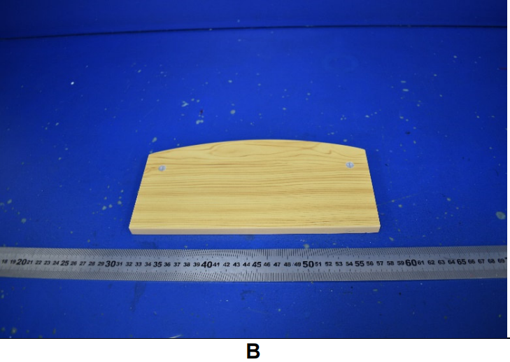
Product name: Kids Storage Box
Item Number: 311-034( TZ-D0034)
Date of Manufacture: 10-APRIL, 2024
Manufacture: TAISHUN ZHENXING TOYS CO., LTD
Address of Manufacture: JIAOYANG INDUSTRIAL PARK,TAISHUN,ZHEJIANG,CHINA,325500
Imported By: Aosom LLC
27150 SW Kinsman Rd
Wilsonville, OR 97070
T: 503.746.5886

Product Reference Image

Testing and Records Overview
Eurofins MTS Consumer Product Testing (Shanghai) Co., Ltd.
No. 105, Guangzhong Road, Minhang, Shanghai, China
Phone: +86 21 61819181-6161
Fax: +86 21 61819180
Lily.Shen@cpt.eurofinscn.com
http://www.eurofins.cn/CPT

Aosom LLC
27150 SW Kinsman Rd
Wilsonville, OR 97070
Corey Shull
T: 503.746.5886
Certification Issued and Test Records Maintained By
Aosom LLC certifies that the above product complies with the following rules, banes, regulations and standards:
Test Location and Contact Information
Test Date: 3-May, 2024
