Children’s Product Certificate
Date of Certificate SEP 02,2021
Product Overview
Product name: kid’s play dressing table
Item Number: 350-144（008-988）
Date of Manufacture: SEP 12,2021
Manufacture: XIONG CHENG PLASTIC TOYs CO.LTD
Address of Manufacture: CHENGHAl DISTRICT SHANTOU CITY GUANGDONG PROVINCE CHINA
Imported By: Aosom LLC
27150 SW Kinsman Rd
Wilsonville, OR 97070
T: 503.746.5886
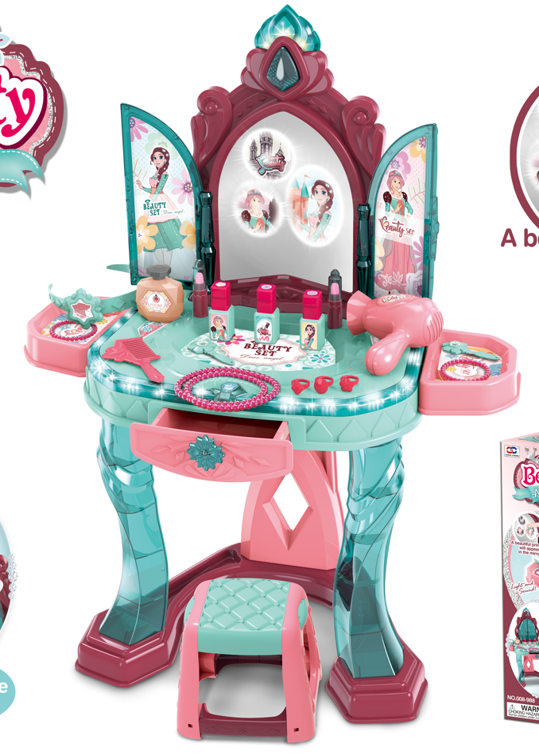

Product Reference Image

Testing and Records Overview
Test Location and Contact Information
Certification Issued and Test Records Maintained By
Aosom LLC
27150 SW Kinsman Rd
Wilsonville, OR 97070
Corey Shull
T: 503.746.5886
SGS-CSTC Standards Technical Co. Ltd
Shenzhen Branch
Room 101-901,1 Pant 4& Room 101,plant2& Room 101,
Pant 3& Rom 301-501,plant3, Janghao (Bantian) industrial
Plant Area, No.430, Jihua Road Bantian Cmmuiy,
Batian Sreet Longgang Dstict Shenzhen, Guangdong,china.
Tel:(86-755) 25328888
Test Date: AUG 04,2021

Aosom LLC certifies that the above product complies with the following rules, banes, regulations and standards:
