Children’s Product Certificate
Date of Certificate May 26,2024
Product Overview
Product name: Kids Rocking Horse
Item Number: 330-161V00PK
Date of Manufacture: May 20,2024
Manufacture: ANHUI TOP WE TOY CO.,LTD.
Address of Manufacture: JINJI TOWN,TIANCHANG CITY,ANHUI PROVINCE,CHINA
Imported By: Aosom LLC
27150 SW Kinsman Rd
Wilsonville, OR 97070
T: 503.746.5886
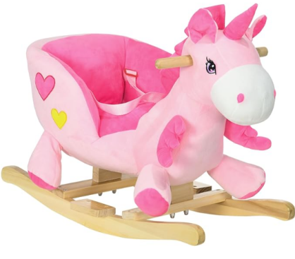

Product Reference Image

Testing and Records Overview
Aosom LLC
27150 SW Kinsman Rd
Wilsonville, OR 97070
Corey Shull
T: 503.746.5886
Eurofins MTS Consumer Product Testing (Shanghai)Co.,Ltd.No.105,Guangzhong Road ，Minhang District,No.8 Fubei Road, Xishan Economic Development .
Email: info.sh@cpt.eurofinscn.com
Certification Issued and Test Records Maintained By
Aosom LLC certifies that the above product complies with the following rules, banes, regulations and standards:
Test Location and Contact Information
Test Date: MAY 10,2024
