Children’s Product Certificate
Date of Certificate MAY. 07 ,2024
Product Overview
Product name: Small various ge ma
Item Number: 330-153V00PK
Date of Manufacture: Mar.25,2024
Manufacture: Yizheng Jian Lin Arts Company
Address of Manufacture: Yizheng City, JiangSu Province, China
Imported By: Aosom LLC
27150 SW Kinsman Rd
Wilsonville, OR 97070
T: 503.746.5886
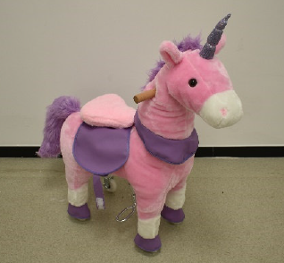

Product Reference Image

Testing and Records Overview
Aosom LLC
27150 SW Kinsman Rd
Wilsonville, OR 97070
Corey Shull
T: 503.746.5886
Eurofins MTS Consumer Product Testing (Shanghai) Co., Ltd.
No. 105, Guangzhong Road, Minhang, Shanghai, China
Phone: +86 21 61819181-6161
Fax: +86 21 61819180
Lily.Shen@cpt.eurofinscn.com
http://www.eurofins.cn/CPT

Certification Issued and Test Records Maintained By
Test Location and Contact Information
Test Date: Apr. 03,2024
Aosom LLC certifies that the above product complies with the following rules, banes, regulations and standards:
Toy Safety Standard, ASTM F 963-23 Physical and Mechanical Hazards
Toy Safety Standard, ASTM F 963-23 Flammability of Toys
Toy Safety Standard, ASTM F 963-23 Heavy Metals
Toy Safety Standard, ASTM F 963-23 Phthalates Content
US CPSIA Section 101: Total Lead Content in Substrate
US CPSIA Section 108: Phthalates Content
US CPSIA Section 101: Total Lead Content in Paint / Surface Coating

