Children’s Product Certificate
Date of Certificate Feb 27,2026
Product Overview
Product name: Baby Tricycle
Item Number: 370-269V00RD (JY-T04）
Date of Manufacture: Dec 29,2025
Manufacture: NINGBO ELITE CYCLE CO.LTD.
Address of Manufacture: NO.36 PUYAN ROAD, XIAPU INDUSTRIAL PARK, BEILUN DISTRICT,NINGBO,CHINA
Imported By: Aosom LLC
7777 Center Ave. Suite 430
Huntington Beach, CA 92647-9998 USA
T:503.746.5886

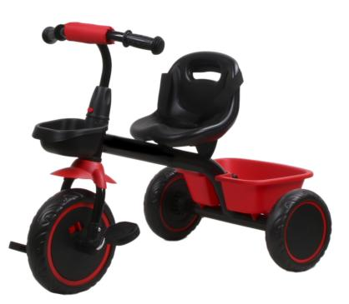

Product Reference Image

Testing and Records Overview
Aosom LLC
7777 Center Ave. Suite 430
Huntington Beach, CA 92647-9998 USA
Corey Shull
T:503.746.5886
corey@aosom.com
Intertek Testing Services Ltd .Zhejiang, Ningbo Branch
4F's Area 2-3 , 5F, No.6 Building,Lingyun Industry
Park, No.1177 Lingyun Road, Ningbo National Hi-Tech
Zone, Ningbo,China,315000
Tel: +86 574 8818 3650
Fax: +86 574 8818 3680
jim.wj.jin@intertek.com

Certification Issued and Test Records Maintained By
Aosom LLC certifies that the above product complies with the following rules, banes, regulations and standards:
Test Location and Contact Information
Test Date: Nov 27, 2025

