Children’s Product Certificate
Date of Certificate MAY 06, 2024
Product Overview
Product name: Rocking horse
Item Number: 330-157
Date of Manufacture: MAY 13, 2024
Manufacture: FUZHOU SUNCHERRY TRADING CO., LTD
Address of Manufacture: NINGBO CITY, ZHEJIANG PROVINCE
Imported By: Aosom LLC
27150 SW Kinsman Rd
Wilsonville, OR 97070
T: 503.746.5886
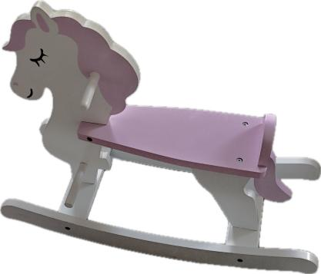

Product Reference Image

Testing and Records Overview
EUROFINS PRODUCT TESTING SERVICE(HANGZHOU) CO., LTD
Room 301-307,Room317-322,3/F., NO.1 Building 1, No.1180,Bin'an Road, Binjiang District,Hangzhou,Zhejiang,China
Phone:+86 571 87203730
CONNIE ZHANG@CPT.EUROFINSCN.COM
Aosom LLC
27150 SW Kinsman Rd
Wilsonville, OR 97070
Corey Shull
T: 503.746.5886
Certification Issued and Test Records Maintained By
Aosom LLC certifies that the above product complies with the following rules, banes, regulations and standards:
Test Location and Contact Information
Test Date:APRIL 19, 2024
