Children’s Product Certificate
Date of Certificate 08-MAY, 2024
Product Overview
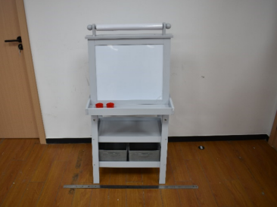
Product name: Kids easel
Item Number: 3B0-012V80GY(TZ-D7001GY)
Date of Manufacture: 10-APRIL, 2024
Manufacture: TAISHUN ZHENXING TOYS CO., LTD
Address of Manufacture: JIAOYANG INDUSTRIAL PARK,TAISHUN,ZHEJIANG,CHINA,325500
Imported By: Aosom LLC
27150 SW Kinsman Rd
Wilsonville, OR 97070
T: 503.746.5886

Product Reference Image

Testing and Records Overview
Eurofins Product Testing Service (Shanghai) Co., Ltd Hangzhou Branch
Room 301-307,3/F., Room 417-422,4/F., No.1 Building 1, No.1180, Bin’an Road, Bingjiang District, Hangzhou, Zhejiang, China
Phone: +86 571 8608 2520
info.hz@eurofins.com

Aosom LLC
27150 SW Kinsman Rd
Wilsonville, OR 97070
Corey Shull
T: 503.746.5886
Certification Issued and Test Records Maintained By
Aosom LLC certifies that the above product complies with the following rules, banes, regulations and standards:
Test Location and Contact Information
Test Date: 15-APR, 2024
