Children’s Product Certificate
Date of Certificate 26-APR-2024
Product Overview
Product name: KID‘S SLIDE SET
Item Number: 331-052V00YL( LY-2889E)
Date of Manufacture: 10-May-2024
Manufacture: Liyou Industrial Co.,Ltd
Address of Manufacture: Yangwan industrial area, QiaoXia Town, Yongjia County,Zhejiang 325106
Imported By: Aosom LLC
27150 SW Kinsman Rd
Wilsonville, OR 97070
T: 503.746.5886
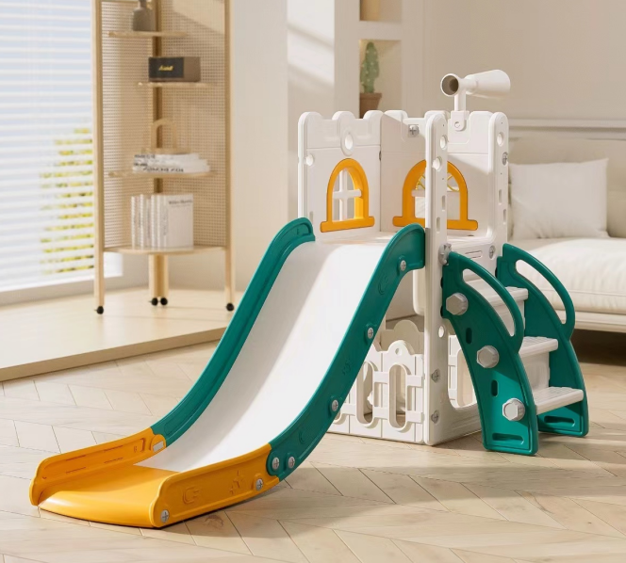

Product Reference Image

Testing and Records Overview
Aosom LLC
27150 SW Kinsman Rd
Wilsonville, OR 97070
Corey Shull
T: 503.746.5886
Certification Issued and Test Records Maintained By
Test Location and Contact Information
SGS-CSTC Standards Technical Services Co., Ltd. , Shenzhen Branch
Room 101-901, Plant 4 & Room 101, Plant 2 & Room 101, Plant 3 & Room 301-501, Plant 3, Jianghao (Bantian) Industrial Plant Area, No.430, Jihua Road, Bantian Cmmunity, Bantian Street, Longgang District, Shenzhen, Guangdong, China 518129
Phone:86-(0)755-83182792
Fax:
chinacomplaint@eurofins. Com
Test Date:19-JAN-2024
Aosom LLC certifies that the above product complies with the following rules, banes, regulations and standards:

