Children’s Product Certificate
Date of Certificate Dec 21,2023
Product Overview
Product name: Kids Soft Play Set
Item Number: 3D0-008
Date of Manufacture: Dec 26,2023
Manufacture: Nantong Tianshu Sports Equipment Co.,Ltd
Address of Manufacture: No.8,Group 5,Zhenhe Village,Chahe Town,Rudong County,Nantong City
Imported By: Aosom LLC
27150 SW Kinsman Rd
Wilsonville, OR 97070
T: 503.746.5886
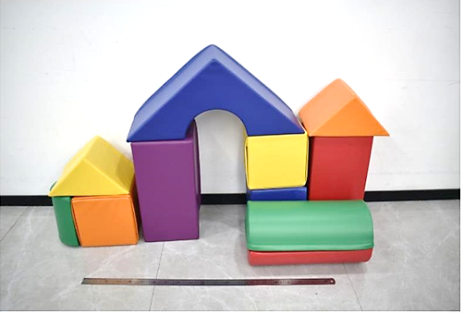

Product Reference Image

Testing and Records Overview
Aosom LLC
27150 SW Kinsman Rd
Wilsonville, OR 97070
Corey Shull
T: 503.746.5886
Eurofins Product Testing Service (Shanghai) Co., Ltd
Building 18, No.2168 Chenhang Highway, Minhang District,
Shanghai, China
Phone: +86 13116656995
Fax:+86 2161819181
SallyZhang@eurofins.com
Certification Issued and Test Records Maintained By
Aosom LLC certifies that the above product complies with the following rules, banes, regulations and standards:
Test Location and Contact Information
Test Date: Dec 12,2023
