Children’s Product Certificate
Date of Certificate Apr 28,2024
Product Overview
Product name: BABY RIDE ON CAR
Item Number: 370-223V00OG
Date of Manufacture: May 25,2024
Manufacture: NINGBO PRINCE TOYS CO.,LTD.
Address of Manufacture: NO.777 EAST TAOYUAN ROAD,GUANHAIWEI TOWN,CIXI CITY,ZHEJIANG,CHINA
Imported By: Aosom LLC
27150 SW Kinsman Rd
Wilsonville, OR 97070
T: 503.746.5886

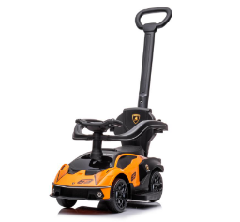

Product Reference Image

Testing and Records Overview
Bureau Veritas Testing Technical Service (Zhejiang) Co.,Ltd
1Fwest,6Feast,7Feast,8F,BuildingB,No.66,QingyiRoad,Ningbo,Zhejiang,China
TUV Rheinland (Shenzhen)Co., Ltd.
1F East & 3F West4F, Cybio Technology Building No.1,No.16 Kejbei 2nd Road,HighTech Industry Park North Nanshan District,518057,Shenzhen, China
Tel:(86)755 82681188·
Fax:(86)75526037102·
Mail: service-gc@tuv.com
Aosom LLC
27150 SW Kinsman Rd
Wilsonville, OR 97070
Corey Shull
T: 503.746.5886
Certification Issued and Test Records Maintained By
Aosom LLC certifies that the above product complies with the following rules, banes, regulations and standards:
Test Location and Contact Information
Test Date: APR 9,2024
