Children’s Product Certificate
Date of Certificate 2026-04-02
Product Overview
Product name: Kids Slide
Item Number: 331-117V00CW
Date of Manufacture: 2026-04-13
Manufacture: FUJIAN FEELBABY TECHNOLOGY CO.,LTD
Address of Manufacture: Beside Wenzhou Avenue,Shuangyue Project Area,Fuding Industrial Zone
Imported By: Aosom LLC
7777 Center Ave.Suite 430
Huntington Beach, CA 92647-9998 USA
T: 877.644.9366
corey@aosom.com
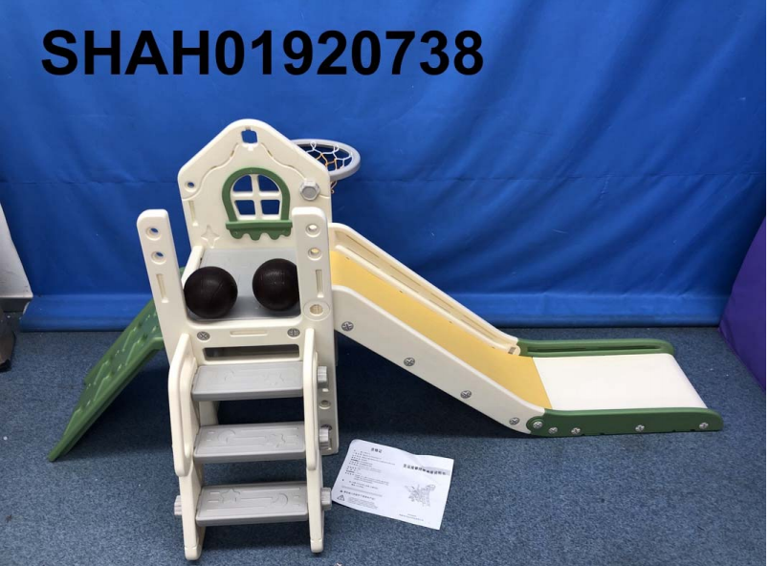

Product Reference Image

Testing and Records Overview
Intertek Testing Services Ltd.,
Shanghai
3/F. of Block D, & Block C, No.1218, Wanrong Road, Jingan District, Shanghai, China
Phone: +86 21 53396000
jim.jin@intertek.com
Aosom LLC
7777 Center Ave.Suite 430
Huntington Beach, CA 92647-9998 USA
T: 877.644.9366
Email:corey@aosom.com

Certification Issued and Test Records Maintained By
Aosom LLC certifies that the above product complies with the following rules, banes, regulations and standards:
Test Location and Contact Information
Test Date: 2026.03.30

