Children’s Product Certificate
Date of Certificate Oct 30，2025
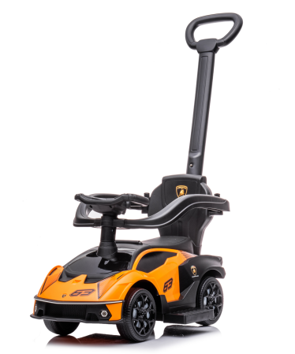

Product Overview
Product name: BABY RIDE ON CAR
Item Number: 370-223V00OG
Date of Manufacture: Sep 25,2025
Manufacture: NINGBO PRINCE TOYS CO.,LTD.
Address of Manufacture: NO.777 EAST TAOYUAN ROAD,GUANHAIWEI TOWN,CIXI CITY,ZHEJIANG,CHINA
Imported By: Aosom LLC
7777 Center Ave. Suite 430
Huntington Beach, CA 92647-9998 USA

Product Reference Image

Testing and Records Overview
TÜV Rheinland (Shenzhen) Co., Ltd
Floor 1-5, Block 5, No. 1100, Huanli Road, Yungu Community, Xinhu Street,
Guangming District, Shenzhen, Guangdong Province, P.R. China Tel.:(86) 755 8268 1188
Aosom LLC
7777 Center Ave. Suite 430
Huntington Beach, CA 92647-9998 USA
corey@aosom.com

Certification Issued and Test Records Maintained By
Aosom LLC certifies that the above product complies with the following rules, banes, regulations and standards:
Test Location and Contact Information
Test Date: Sep 26,2025

