Children’s Product Certificate
Date of Certificate May 28 2024
Product Overview
Product name: Swing Stand
Item Number: 344-035
Date of Manufacture: June 3, 2024
Manufacture: JINHUA DKS SPORTS GOODS CO., LTD
Address of Manufacture: DONGXI INDUSTRY ZONE, BAOLONGQIAO TOWN, WUCHENG, JINHUA
Imported By: Aosom LLC
27150 SW Kinsman Rd
Wilsonville, OR 97070
T: 503.746.5886
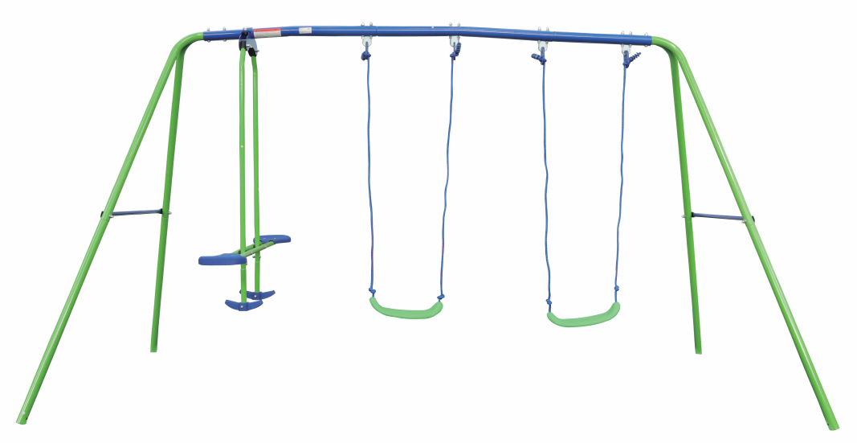

Product Reference Image

Testing and Records Overview
Ningbo GIG Testing Co., Ltd
No. 55, Fuqiang Road, Yinzhou District, Ningbo, Zhejiang, China
Tel: +86-574-89201291
www. gig-lab.com
www.gigqc.com

Aosom LLC
27150 SW Kinsman Rd
Wilsonville, OR 97070
Corey Shull
T: 503.746.5886
Certification Issued and Test Records Maintained By

Aosom LLC certifies that the above product complies with the following rules, banes, regulations and standards:
Test Location and Contact Information
Test Date: April 23,2024

