Children’s Product Certificate
Date of Certificate 20 Nov, 2025
Product Overview
Product name: Software Composite Toy
Item Number: 3D0-011
Date of Manufacture: 10 Oct,2025
Manufacture: NINGBO YINZHOU WANLI SPORTING GOODS CO., LTD
Address of Manufacture: NO. 218-2, LISHUTANG, PINGTANG INDUSTRIAL ZONE, DONGWU TOWN, ZHEJIANG PROVINCE, CHINA
Imported By: Aosom LLC
27150 SW Kinsman Rd
Wilsonville, OR 97070
T: 503.746.5886
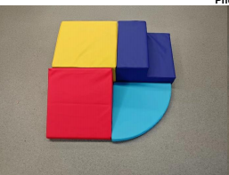

Product Reference Image

Testing and Records Overview
Intertek Testing Services Ltd .Zhejiang, Ningbo
Branch
4F's Area 2-3 , 5F, No.6 Building,Lingyun Industry
Park, No.1177 Lingyun Road, Ningbo National Hi-Tech Zone, Ningbo,China,315000
Tel: +86 574 88183650
Fax: +86 574 8818 3680

Aosom LLC
27150 SW Kinsman Rd
Wilsonville, OR 97070
Corey Shull
T: 503.746.5886
corey@aosom.com

Certification Issued and Test Records Maintained By

Aosom LLC certifies that the above product complies with the following rules, banes, regulations and standards:
Test Location and Contact Information
Test Date: 30 Oct, 2025

