Children’s Product Certificate
Date of Certificate May. 07,2024
Product Overview
Product name: Children Car
Item Number: 370-148V80(JJ2077)
Date of Manufacture: Mar. 07,2024
Manufacture: ZHEJIANG JIAJIA RIDE-ON CO.,LTD
Address of Manufacture: PINGHU CITY, ZHEJIANG PROVINCE
Imported By: Aosom LLC
27150 SW Kinsman Rd
Wilsonville, OR 97070
T: 503.746.5886
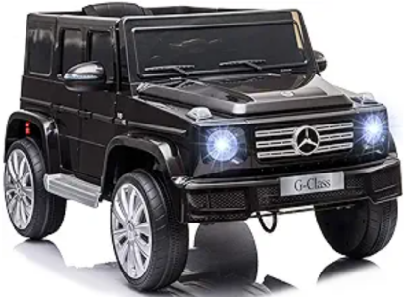

Product Reference Image

Testing and Records Overview
Aosom LLC
27150 SW Kinsman Rd
Wilsonville, OR 97070
Corey Shull
T: 503.746.5886
Intertek Testing Services Wuxi Ltd.
No.8 Fubei Road, Xishan Economic Development
Zone, Wuxi, Jiangsu, China. 214101
Tel: +86 510 8821 4567
Fax: +86 510 8820 0428
www.intertek.com
Certification Issued and Test Records Maintained By
Aosom LLC certifies that the above product complies with the following rules, banes, regulations and standards:
Test Location and Contact Information
Test Date: Apr. 30,2024
