Children’s Product Certificate
Date of Certificate December 13, 2025
Product Overview
Product name: Toy Car
Item Number: 370-426V80BU (HZB-1528)
Date of Manufacture: December 30, 2025
Manufacture: CHIZHOU HAIZHIBAO CHILDREN PRODUCTS CO., LTD
Address of Manufacture: MATANG INDUSTRIAL PARK, DINGQIAO TOWN, QINGYANG COUNTY, CHIZHOU CITY,CHINA
Imported By: Aosom LLC
7777 Center Ave. Suite 430
Huntington Beach, CA 92647-9998 USA
T: 503.746.5886
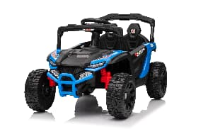

Product Reference Image

Testing and Records Overview
Aosom LLC
7777 Center Ave. Suite 430
Huntington Beach, CA 92647-9998 USA
Corey Shull
T:503.746.5886
corey@aosom.com

Intertek Testing Services Shenzhen Ltd.
West Side of 1/F and 3,4,5/F of Bldg. 1, 1-5/F of Bldg. 3, Yuanzheng Science and Technology Industrial Park, No.4012, Wuhe Ave. North, Bantian Street, Longgang District, Shenzhen,China
Tel:+86755 26020111
Certification Issued and Test Records Maintained By
Aosom LLC certifies that the above product complies with the following rules, banes, regulations and standards:
Test Location and Contact Information
Test Date: September 28,2025

