Children’s Product Certificate
Date of Certificate Nov. 3, 2025
Product Overview
Product name: CHILDREN’S CAR
Item Number: 370-149V80RD(JS370)
Date of Manufacture: Mar. 25th, 2026
Manufacture: ZHEJIANG JIAJIA RIDE-ON CO.,LTD
Address of Manufacture: XINCANG INDUSTRIAL ZONE PINGHU CITY, ZHEJIANG PROVINCE ,CHINA
Imported By: Aosom LLC
7777 Center Ave. Suite 430
Huntington Beach, CA 92647-9998 USA
T: 503.746.5886
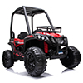

Product Reference Image

Testing and Records Overview
Aosom LLC
7777 Center Ave. Suite 430
Huntington Beach, CA 92647-9998 USA
Corey Shull
T:503.746.5886
corey@aosom.com

Intertek Testing Services Wuxi Ltd.
No.8 Fubei Road, Xishan Economic Development
Zone, Wuxi, Jiangsu, China. 214101
Tel: +86-510-88214567
Fax: +86-510-88200428
E-mail：jim.jin@intertek.com
Certification Issued and Test Records Maintained By
Aosom LLC certifies that the above product complies with the following rules, banes, regulations and standards: 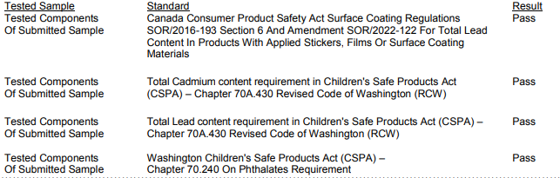
Test Location and Contact Information
Test Date: 26 Sep, 2025 To 03 Nov, 2025
