Children’s Product Certificate
Date of Certificate MAY 13, 2024
Product Overview
Product name: Electric Ride-on Car
Item Number: 370-260V80WT（JC915）
Date of Manufacture: 2024-05-15
Manufacture: PINGHU XH CHILDREN PRODUCTS CO., LTD
Address of Manufacture: NO.186, TONGCHE TOWN ROAD, XINCANG TOWN, PINGHU CITY, ZHEJIANG PROVINCE
Imported By: Aosom LLC
27150 SW Kinsman Rd
Wilsonville, OR 97070
T: 503.746.5886
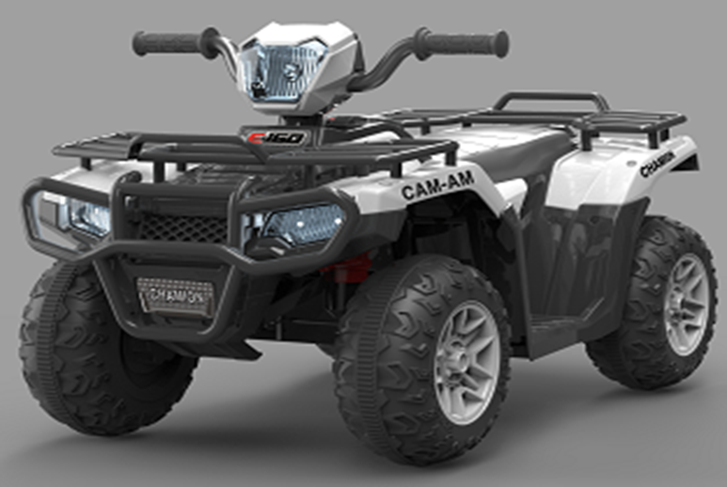

Product Reference Image

Testing and Records Overview
Test Location and Contact Information
Test Date: 13-May-2024
Aosom LLC
27150 SW Kinsman Rd
Wilsonville, OR 97070
Corey Shull
T: 503.746.5886
Eurofins MTS Consumer Product Testing (Shanghai)Co., Ltd.
NO.105 GUANGZHONG RD., ZHUANQIAO TOWN
MINHANG, SHANGHAI, SHANGHAI CHINA 201108
Phone: +86-21-23509688
Fax: +86-21-23509700
CLEMENT.LI@CPT.EUROFINSCN.COM

Bureau Veritas Testing Technical Service (Zhejiang) Co., Ltd.
1/F. & 6/F. & 7/F. & 8/F., BLOCK B, NO.66, QINGYI ROAD, HI-TECH ZONE, NINGBO, ZHEJIANG, CHINA
NINGBO, ZHEJIANG CHINA 315040
PHONE: 86-574-87912121
FAX: 86-574-87907993
EMAIL ADDRESS: CANDY.YU@BUREAUVERITAS.COM

Certification Issued and Test Records Maintained By
Aosom LLC certifies that the above product complies with the following rules, banes, regulations and standards:
