Children’s Product Certificate
Date of Certificate Dec 03, 2025
Product Overview
Product name: Ride On Car
Item Number: 370-390V80WT (SX2538)
Date of Manufacture: Dec 15, 2025
Manufacture:
PINGHU SHUANGXI BABY CARRIER MANUFACTURE CO.,LTD
Address of Manufacture:
XINCANG TOWN, PINGHU CITY, ZHEJIANG PROVINCE, CHINA
Imported By: Aosom LLC
7777 Center Ave. Suite 430
Huntington Beach, CA 92647-9998 USA

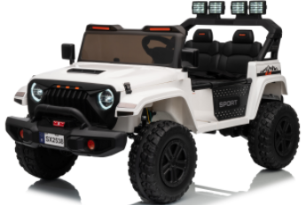

Product Reference Image

Testing and Records Overview
Aosom LLC

7777 Center Ave. Suite 430
Huntington Beach, CA 92647-9998 USA
corey@aosom.com

SGS-CSTC Standards Technical Services (Changzhou) Co., Ltd.
1st, 2nd, 6th Floors, Building 30, Heimudan Science Park, Tianning District, Changzhou, Jiangsu, China
Tel.: (86-519) 85587753 Mail: sgs.china@sgs.com
Web: www.sgsgruop.com.cn
Test Location and Contact Information
Test Date:Oct 10, 2025 to Dec 03, 2025

Certification Issued and Test Records Maintained By
Aosom LLC certifies that the above product complies with the following rules, banes, regulations and standards:

