Children’s Product Certificate
Date of Certificate Nov.6th, 2023
Product Overview
Product name: Kid’s Sandbox
Item Number: 343-029V00RD (2076)
Date of Manufacture: Nov.10th, 2023
Manufacture: Fujian Zhangping D-road Forestry Co.,Ltd.
Address of Manufacture: Fushan Industry District, Zhangping City, Fujian, China
Imported By: Aosom LLC
27150 SW Kinsman Rd
Wilsonville, OR 97070
T: 503.746.5886
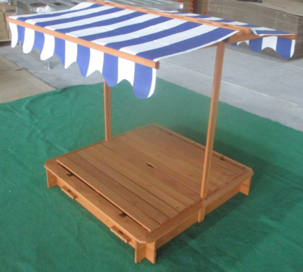

Product Reference Image

Testing and Records Overview
Aosom LLC
27150 SW Kinsman Rd
Wilsonville, OR 97070
Corey Shull
T: 503.746.5886
Test Location and Contact Information
Eurofins Product Testing Service (Shanghai) Co., Ltd. Hangzhou Brance
Room 301-307, 3/F., Room 417-422,4/F.,NO.1 Building,NO.1180, Bin’an Road, Binjiang District, Hangzhou,Zhejiang, China
Phone: +86 0571 86082520
Fax: +86 0571 8720 3729
Joy.Lai@cpt.eurofins.com
Certification Issued and Test Records Maintained By
Test Date: Oct. 30, 2023
Aosom LLC certifies that the above product complies with the following rules, banes, regulations and standards:
