Children’s Product Certificate
Date of Certificate Aug 5,2025
Product Overview
Product name: RIDE ON CAR
Item Number: 370-446V80BU (SX1968)
Date of Manufacture: AUG 10,2025
Manufacture:
PINGHU SHUANGXI BABY CARRIER MANUFACTURE CO.,LTD
Address of Manufacture:
XINCANG TOWN, PINGHU CITY, ZHEJIANG PROVINCE, CHINA
Imported By: Aosom LLC
27150 SW Kinsman Rd
Wilsonville, OR 97070
T: 503.746.5886
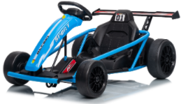

Product Reference Image

Testing and Records Overview
Aosom LLC
27150 SW Kinsman Rd
Wilsonville, OR 97070
Corey Shull
T: 503.746.5886
Shenzhen MTL Testing Technology Co., Ltd.
305, Building A, Shenghengji Industrial Park, No.137, Fuyuan 1st Road, Zhancheng Community, Fuhai Street, Bao'an District, Shenzhen, Guangdong, China
Tel:+ (86)0755 23143231
EMAIL ADDRESS:Jason@mtl-lab.com

Test Location and Contact Information
Test Date:Jun 24, 2025 to Aug 5, 2025

Certification Issued and Test Records Maintained By
Aosom LLC certifies that the above product complies with the following rules, banes, regulations and standards:

