Children’s Product Certificate
Date of Certificate April 5,2024
Product Overview
Product name: Children Car
Item Number: 370-283V80RD（AHL008）
Date of Manufacture: April 1,2024
Manufacture: ANHUI HARLEY BABY CAR CO.,LTD.
Address of Manufacture: CHUZHOU CITY, ANHUI PROVINCE
Imported By: Aosom LLC
27150 SW Kinsman Rd
Wilsonville, OR 97070
T: 503.746.5886
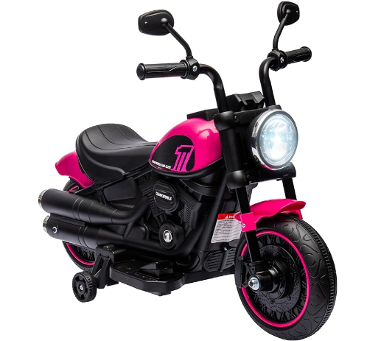

Product Reference Image

Testing and Records Overview
Aosom LLC
27150 SW Kinsman Rd
Wilsonville, OR 97070
Corey Shull
T: 503.746.5886
Eurofins Product Testing Service (Hangzhou) Co., Ltd.
Room 301-307,3/F., Room 417-422,4/F., NO.1 Building 1, No.1180, Bin’an Road, Binjiang District, Hangzhou, Zhejiang, China

Certification Issued and Test Records Maintained By
Aosom LLC certifies that the above product complies with the following rules, banes, regulations and standards: 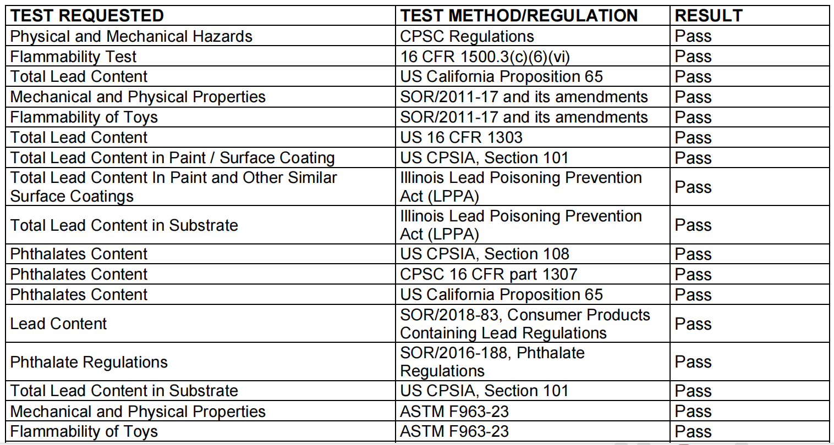
Test Location and Contact Information
Test Date: Mar 28,2024

