Children’s Product Certificate
Date of Certificate:03-JUN-2024
Product Overview
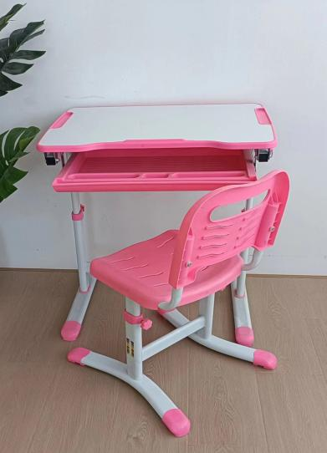
Product name: KIDS STUDY DESK AND CHAIR SET
Item Number: 312-064V81PK（Z-03+Y03）
Date of Manufacture: 27-JUNE-2024
Manufacture: ZHEJIANG XIAOYUER INDUSTRY AND TRADE CO. LTD.
Address of Manufacture: No.9 Guihua Road,Baihuashan Industrial Park, Wuyi,Zhejiang, China
Imported By: Aosom LLC
27150 SW Kinsman Rd
Wilsonville, OR 97070
T: 503.746.5886

Product Reference Image

Testing and Records Overview
Certification Issued and Test Records Maintained By
Test Location and Contact Information
Test Date:17-APR-2024 To 03-JUN-2024
Intertek Testing Services Ltd., Shanghai
ADD：1-5/F., Block C, No.1218, Wanrong Road, Jingan District, Shanghai, China
Tel：+86 21 53396000
E-Mail： Jim.wj.jin@intertek.com
Aosom LLC
27150 SW Kinsman Rd
Wilsonville, OR 97070
Corey Shull
T: 503.746.5886
Aosom LLC certifies that the above product complies with the following rules, banes, regulations and standards:
