Children’s Product Certificate
Date of Certificate Apr 8，2026
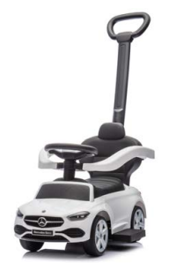

Product Overview
Product name: BABY RIDE ON CAR
Item Number: 370-441V00WT
Date of Manufacture: Apr 8，2026
Manufacture: NINGBO PRINCE TOYS CO.,LTD.
Address of Manufacture: NO.777 EAST TAOYUAN ROAD,GUANHAIWEI TOWN,CIXI CITY,ZHEJIANG,CHINA
Imported By: Aosom LLC
7777 Center Ave. Suite 430
Huntington Beach, CA 92647-9998 USA

Product Reference Image

Testing and Records Overview
Aosom LLC
7777 Center Ave. Suite 430
Huntington Beach, CA 92647-9998 USA
Corey Shull
Email:corey@aosom.com

Bureau Veritas Testing Technical Service
(Zhejiang) Co.,Ltd
1F west, 6F east, 7F east, 8F, Building B,
No.66,Qingyi Road, Ningbo, Zhejiang, China
Tel:86-574-87091333
llyli.li@bureauveritas.com
Certification Issued and Test Records Maintained By
Aosom LLC certifies that the above product complies with the following rules, banes, regulations and standards:
Test Location and Contact Information
Test Date: Mar 17,2025
