Children’s Product Certificate
Date of Certificate May. 27,2024
Product Overview
Product name: RIDE ON CAR
Item Number: 370-312V00RD(7658)
Date of Manufacture: May. 22,2024
Manufacture: YIWU ZHIHUIXING TOYS CO.,LTD
Address of Manufacture: 189 QIUSHI ROAD, BEIYUAN DISTRICT, YIWU, ZHEJIANG, CHINA.
Imported By: Aosom LLC
27150 SW Kinsman Rd
Wilsonville, OR 97070
T: 503.746.5886
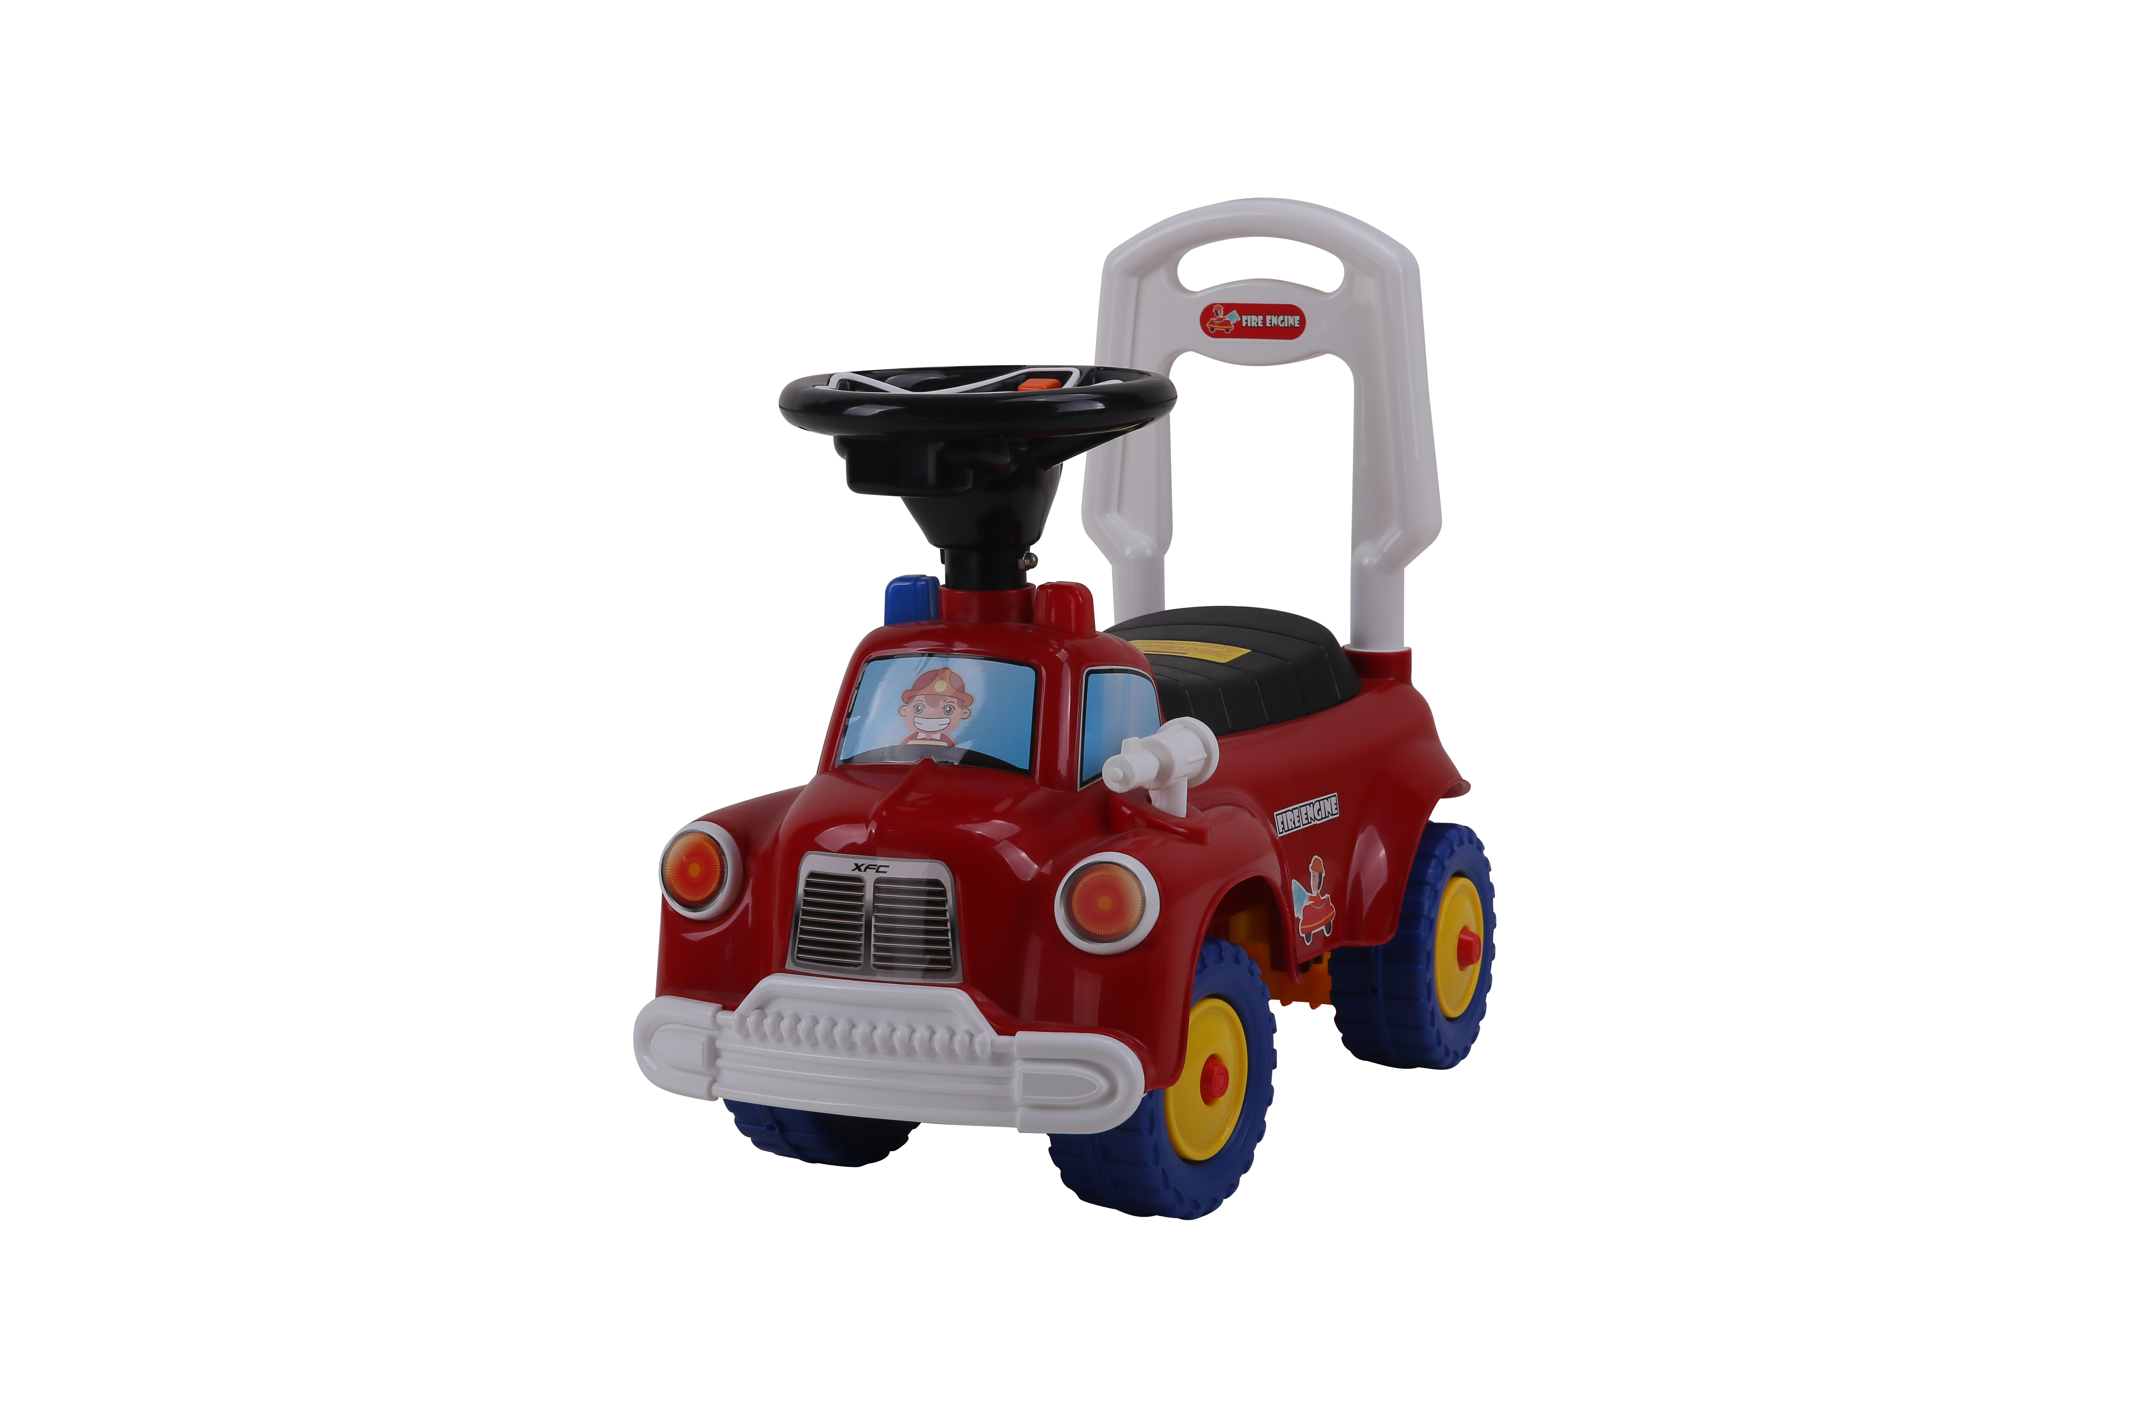

Product Reference Image

Testing and Records Overview
Aosom LLC
27150 SW Kinsman Rd
Wilsonville, OR 97070
Corey Shull
T: 503.746.5886
Intertek Testing Services Ltd .Zhejiang, Ningbo Branch

5/F No. 6 Building, Lingyun Industry Park, No.1177
Lingyun Road, Ningbo National Hi-Tech Zone, Ningbo,
China, 3150001
Certification Issued and Test Records Maintained By
Aosom LLC certifies that the above product complies with the following rules, banes, regulations and standards:
Test Location and Contact Information
Test Date: May. 15,2024

