Children’s Product Certificate
Date of Certificate April 17,2024
Product Overview
Product name: GO KART
Item Number: 341-025（2036E）
Date of Manufacture: Feb. 26, 2024
Manufacture: JINJIANG NOBEL STAR TOYS CO., LTD.
Address of Manufacture: JINJIANG CITY, FUJIAN PROVINCE
Imported By: Aosom LLC
27150 SW Kinsman Rd
Wilsonville, OR 97070
T: 503.746.5886
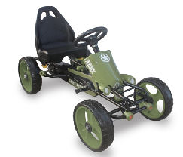

Product Reference Image
Test Date: FEB. 06,2024
Test Location and Contact Information
Testing and Records Overview
Eurofins MTS Consumer Product Testig (ShaiHai) Co., Ltd.
No. 105, GuangZhong Road, Minhang, Shanghai, China

Aosom LLC
27150 SW Kinsman Rd
Wilsonville, OR 97070
Corey Shull
T: 503.746.5886
Certification Issued and Test Records Maintained By
Aosom LLC certifies that the above product complies with the following rules, banes, regulations and standards:
