Children’s Product Certificate
Date of Certificate Jan. 30,2024
Product Overview
Product name: Children Car
Item Number: 370-335V80BU(JT5006)
Date of Manufacture: June. 10,2024
Manufacture: ZHEJIANG JIAJIA RIDE-ON CO.,LTD
Address of Manufacture: PINGHU CITY, ZHEJIANG PROVINCE
Imported By: Aosom LLC
27150 SW Kinsman Rd
Wilsonville, OR 97070
T: 503.746.5886
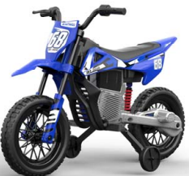

Product Reference Image

Testing and Records Overview
Aosom LLC
27150 SW Kinsman Rd
Wilsonville, OR 97070
Corey Shull
T: 503.746.5886
SGS-CSTC standards Techincal Service (Changzhou) CO.,LTD
Building 30,No.47,QingyangNorth Road,Tianning District,Changzhou,China,23017
Certification Issued and Test Records Maintained By
Aosom LLC certifies that the above product complies with the following rules, banes, regulations and standards:
Test Location and Contact Information
Test Date: Jan 30,2024

