Children’s Product Certificate
Date of Certificate 4-DEC, 2025
Product Overview
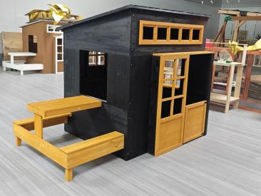
Product name: WOODEN PLAYHOUSE
Item Number: 345-039V00BK
Date of Manufacture: NOV 25,2025
Manufacture: GUTIAN COUNTY MORIXU INDUSTRY AND TRADE CO., LTD.
Address of Manufacture: NO. 10, HANTOULING, SOUTH SIZHI ROAD, 614 ROAD, CHENGXI STREET,NINDER FUJIAN CHINA
Imported By: Aosom LLC
27150 SW Kinsman Rd
Wilsonville, OR 97070
T: 503.746.5886

Product Reference Image

Testing and Records Overview
Certification Issued and Test Records Maintained By
Aosom LLC
27150 SW Kinsman Rd
Wilsonville, OR 97070
Corey Shull
T: 503.746.5886
Zhejiang J-Testing Service Co.,ltd West of 3rd Floor, No. 5 No.968 Xuefeng West Road, Beiyuan Street, Yiwu,Zhejiang,China 322000
Phone: +86 057985309611
info. www.jts-cert.com

Test Location and Contact Information
Test Date: DEC 26,2023
Aosom LLC certifies that the above product complies with the following rules, banes, regulations and standards:
