Children’s Product Certificate
Date of Certificate APR 28,2024
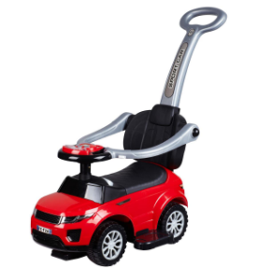
Product Overview
Product name: BABY RIDE ON CAR
Item Number: 370-116RD
Date of Manufacture: Jul 2,2024
Manufacture: NINGBO PRINCE TOYS CO.,LTD.
Address of Manufacture: NO.777 EAST TAOYUAN ROAD,GUANHAIWEI TOWN,CIXI CITY,ZHEJIANG,CHINA
Imported By: Aosom LLC
27150 SW Kinsman Rd
Wilsonville, OR 97070
T: 503.746.5886

Product Reference Image

Testing and Records Overview
Bureau Veritas Testing Technical Service (Zhejiang) Co.,Ltd
1F west,6F east,7F east,8F,Building B,No.66,Qingyi Road,Ningbo,Zhejiang,China
Tel:86-574-87091333,Fax:86-574-87971038
website:cps.bureauveritas.com
Aosom LLC
27150 SW Kinsman Rd
Wilsonville, OR 97070
Corey Shull
T: 503.746.5886
Certification Issued and Test Records Maintained By
Aosom LLC certifies that the above product complies with the following rules, banes, regulations and standards:
Test Location and Contact Information
Test Date: APR 9,2024

