Children’s Product Certificate
Date of Certificate Oct. 21, 2025
Product Overview
Product name: Trampoline
Item Number: 342-083V00CG
Date of Manufacture: Oct. 30, 2025
Manufacture: MIJUMP SPORTS CO., LTD.
Address of Manufacture: JINHU CITY, JIANGSU PROVINCE, CHINA
Imported By: Aosom LLC
27150 SW Kinsman Rd
Wilsonville, OR 97070
T: 503.746.5886
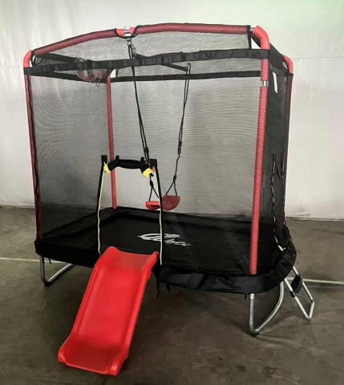

Product Reference Image

Testing and Records Overview
NINGBO GIG testing Co., Ltd.
No.555 Fuqiang road, Yinzhou District ,Ningbo, Zhejiang, China
Phone: +86 574 89201291
E-mail:ramon.yan@gig-lab.com
www.gig-lab.com

Test Location and Contact Information
Aosom LLC
27150 SW Kinsman Rd
Wilsonville, OR 97070
Corey Shull
T: 503.746.5886
Certification Issued and Test Records Maintained By
Test Date: Oct. 10, 2025
Aosom LLC certifies that the above product complies with the following rules, banes, regulations and standards:

