Children’s Product Certificate
Date of Certificate Apr 01, 2024
Product Overview
Product name: Ride On Car
Item Number: 370-303V80BU (HLY8888)
Date of Manufacture: Feb 01,2024
Manufacture:
PINGHU SHUANGXI BABY CARRIER MANUFACTURE CO.,LTD
Address of Manufacture:
XINCANG TOWN, PINGHU CITY, ZHEJIANG PROVINCE, CHINA
Imported By: Aosom LLC
27150 SW Kinsman Rd
Wilsonville, OR 97070
T: 503.746.5886
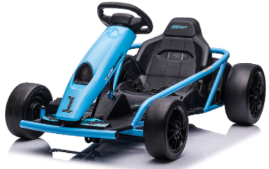

Product Reference Image

Testing and Records Overview
Aosom LLC
27150 SW Kinsman Rd
Wilsonville, OR 97070
Corey Shull
T: 503.746.5886
Bureau Veritas Testing Technical Service (Zhejiang) Co.,Ltd
1F west, 6F east, 7F east, 8F, Building B,No.66,Qingyi Road, Ningbo, Zhejiang, China
Tel.: 86-574-87091330 Mail: allen.he@bureauveritas.com Web:www.cps.bureauveritas.com
Test Location and Contact Information
Test Date: Feb 22,2024

Certification Issued and Test Records Maintained By
Aosom LLC certifies that the above product complies with the following rules, banes, regulations and standards:

