Children’s Product Certificate
Date of Certificate 04 Jul,2024
Product Overview
Product name: Climbing Arch for Kids
Item Number: PHAS-019/347-021V01MX
Date of Manufacture: 25 Jul,2024
Manufacture: CAOXIAN PENGHUI ARTS & CRAFTS CO., LTD
Address of Manufacture: NIJI ROAD, CAO COUNTY SMALL AND MEDIUM ENTERPRISE INCUBATOR PARK, CAO COUNTY, HEZE CITY, SHANDONG PROVINCE
Imported By: Aosom LLC
27150 SW Kinsman Rd
Wilsonville, OR 97070
T: 503.746.5886
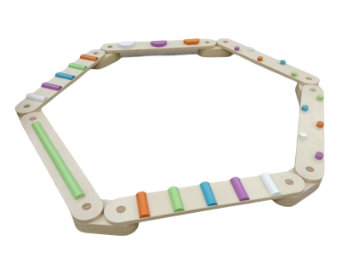

Product Reference Image

Testing and Records Overview
Aosom LLC
27150 SW Kinsman Rd
Wilsonville, OR 97070
Corey Shull
T: 503.746.5886
Certification Issued and Test Records Maintained By
INTERTEK TESTING SERVICES LTD.ZHEJIANG
Building No.2, Juanhu Science and Technology
Innovation Park, No. 500 East Shuiyueting Road,
Haining City, Zhejiang Province,China. 314400
Phone:+86 573 87137200
Fax:+86 573 87137122
E-mail:jim.wj.jin@intertek.com
Aosom LLC certifies that the above product complies with the following rules, banes, regulations and standards:
Test Location and Contact Information
Test Date: May 24, 2024

