Children’s Product Certificate
Date of Certificate 2024-06-21
Product Overview
Product name: Electric ride on toy
Item Number: 370-104(QLS-802)
Date of Manufacture: 2024-04-30
Manufacture: PINGHU QILESHI BABY CARRIER CO., LTD
Address of Manufacture: NO.1698 CANGDONG ROAD XINCANG
TOWN PINGHU CITY ZHEJIANG PROVINCE
Imported By: Aosom LLC
27150 SW Kinsman Rd
Wilsonville, OR 97070
T: 503.746.5886

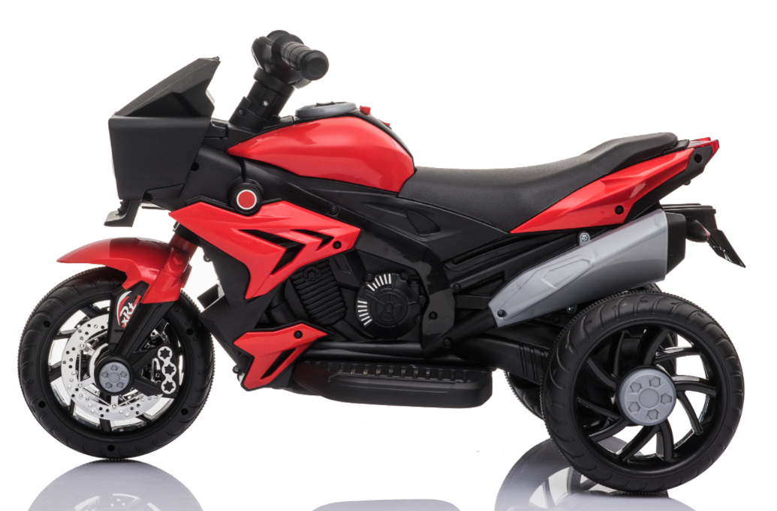

Product Reference Image

Testing and Records Overview
INTERTEK TESTING SERVICES WUXI LTD.
No.8 Fubei Road, Xishan Economic Development
Zone, Wuxi, Jiangsu, China. 214101
Phone: +86 510 88214567
www.intertek.com

Aosom LLC
27150 SW Kinsman Rd
Wilsonville, OR 97070
Corey Shull
T: 503.746.5886
Certification Issued and Test Records Maintained By
Aosom LLC certifies that the above product complies with the following rules, banes, regulations and standards:
Test Location and Contact Information
Test Date: 2024.05.07-06.19

