Children’s Product Certificate
Date of Certificate April. 17, 2024
Product Overview
Product name: CHILDREN ELECTRONIC ORGAN
Item Number: 390-020PK（3132C）
Date of Manufacture: April 30,2024
Manufacture: GUANGDONG BAOLI CULTURAL DEVELOPMENT
CO., LTD.
Address of Manufacture: NO.2 CROSS-WEST ROAD, FENGXIN GANGKOU INDUSTRIAL SECTION, FENGXIANG STREET, CHENGHAI, SHANTOU, GUANGDONG PROVINCE, CHINA

Imported By: Aosom LLC
27150 SW Kinsman Rd
Wilsonville, OR 97070
T: 503.746.5886
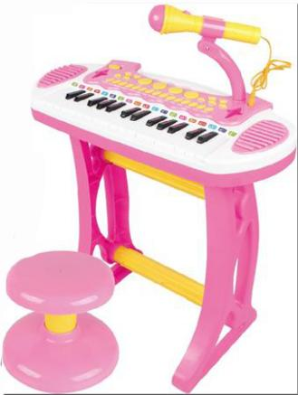

Product Reference Image

Testing and Records Overview

Aosom LLC certifies that the above product complies with the following rules, banes, regulations and standards:
Test Location and Contact Information
Test Date: March 25, 2024
Certification Issued and Test Records Maintained By
Aosom LLC
27150 SW Kinsman Rd
Wilsonville, OR 97070
Corey Shull
T: 503.746.5886
Intertek Testing Services Shenzhen Limited Room 401/501/601/801/901/1003,No.8,East BaoYing Road, Huangpu District, Guangzhou, China /111, Huichuang Kongjian, TCL Cultural Industrial Park, No.69, Guangpu Road, Huangpu, District, Guangzhou, Guangdong, China.
Tel: +8620 28209114 intertek.com.cn
intertek.com
