Children’s Product Certificate
Date of Certificate 2024-04-17
Product Overview
Product name: Toy Storage Cabinet
Item Number: 311-046ND
Date of Manufacture: 2024-04-17
Manufacture: Ningbo Moke Intelligent Technology Co., Ltd
Address of Manufacture: NO.188 Qishan Road,Yinzhou Economic District,Ningbo City,Zhejiang,China
Imported By: Aosom LLC
27150 SW Kinsman Rd
Wilsonville, OR 97070
T: 503.746.5886
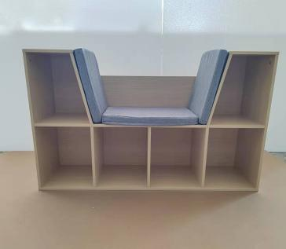

Product Reference Image

Testing and Records Overview
Eurofins MTS Comsumer Product Testing(Shanghai Co.,Ltd.
No. 105,Guangzhong Road,Minhang,Shanghai,China
Phone: + 86-21- 2350 9600
infosh@cpt.eurofinscn.com
Aosom LLC
27150 SW Kinsman Rd
Wilsonville, OR 97070
Corey Shull
T: 503.746.5886
Certification Issued and Test Records Maintained By
Aosom LLC certifies that the above product complies with the following rules, banes, regulations and standards: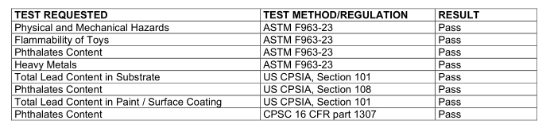
Test Location and Contact Information
Test Date: 2024.04.17

